

**ACADEMIC SESSION: Semester 1, 2023/2024**

**CAT201 - INTEGRATED SOFTWARE DEVELOPMENT WORKSHOP**

**ASSIGNMENT 2**

**Exploring and applying modern web development tools and principles of GUI design**

**Lecturer: Assoc. Prof. Dr. Chan Huah Yong**

**GROUP MEMBERS**

| **NAME** | **MATRIC NUMBER** | **EMAIL** |
| --- | --- | --- |
| **Masood Abdulrahman Abdullah Saeed** | **160233** | **masood@student.usm.my** |
| **Mohsin Ali** | **165381** | **20july2003mohsin@student.usm.my** |
| **Abdelrahman Hamdy Fergany** | **160703** | **abdelrahman@student.usm.my** |
| **Azam Tamheed** | **160610** | **azamtamheed@student.usm.my** |

**PREPARED BY**

**GROUP 31**

**Table of Content**

**1. Design Screenshots 2**

1.1 Top Section & Navbar 2

1.2 Meals 3

1.3 Drinks 4

1.4 Newsletter Subscription 5

1.5 Team 5

1.6 Footer

6

**2. Individual Scope 8**

2.1 Abdelrahman Hamdy Fergany (UI/UX Designer): 8

2.2 Masood Abdulrahman Abdullah Masood, Frontend Developer (Main Components): 8

2.3 Mohsin Ali, Frontend Developer (Card Components): 8

2.4 Azam Tamheed, Integration (Ensuring Coherence):

8

**3. Developmental and Design Work 9**

3.1 Abdelrahman Hamdy Fergany (UI/UX Designer): 9

3.2 Masood Abdulrahman Abdullah Masood, Frontend Developer (Main Components): 9

3.3 Mohsin Ali, Frontend Developer (Card Components): 9

3.4 Azam Tamheed (Integration): 9

# **Design Screenshots**

## **1.1 Top Section & Navbar**

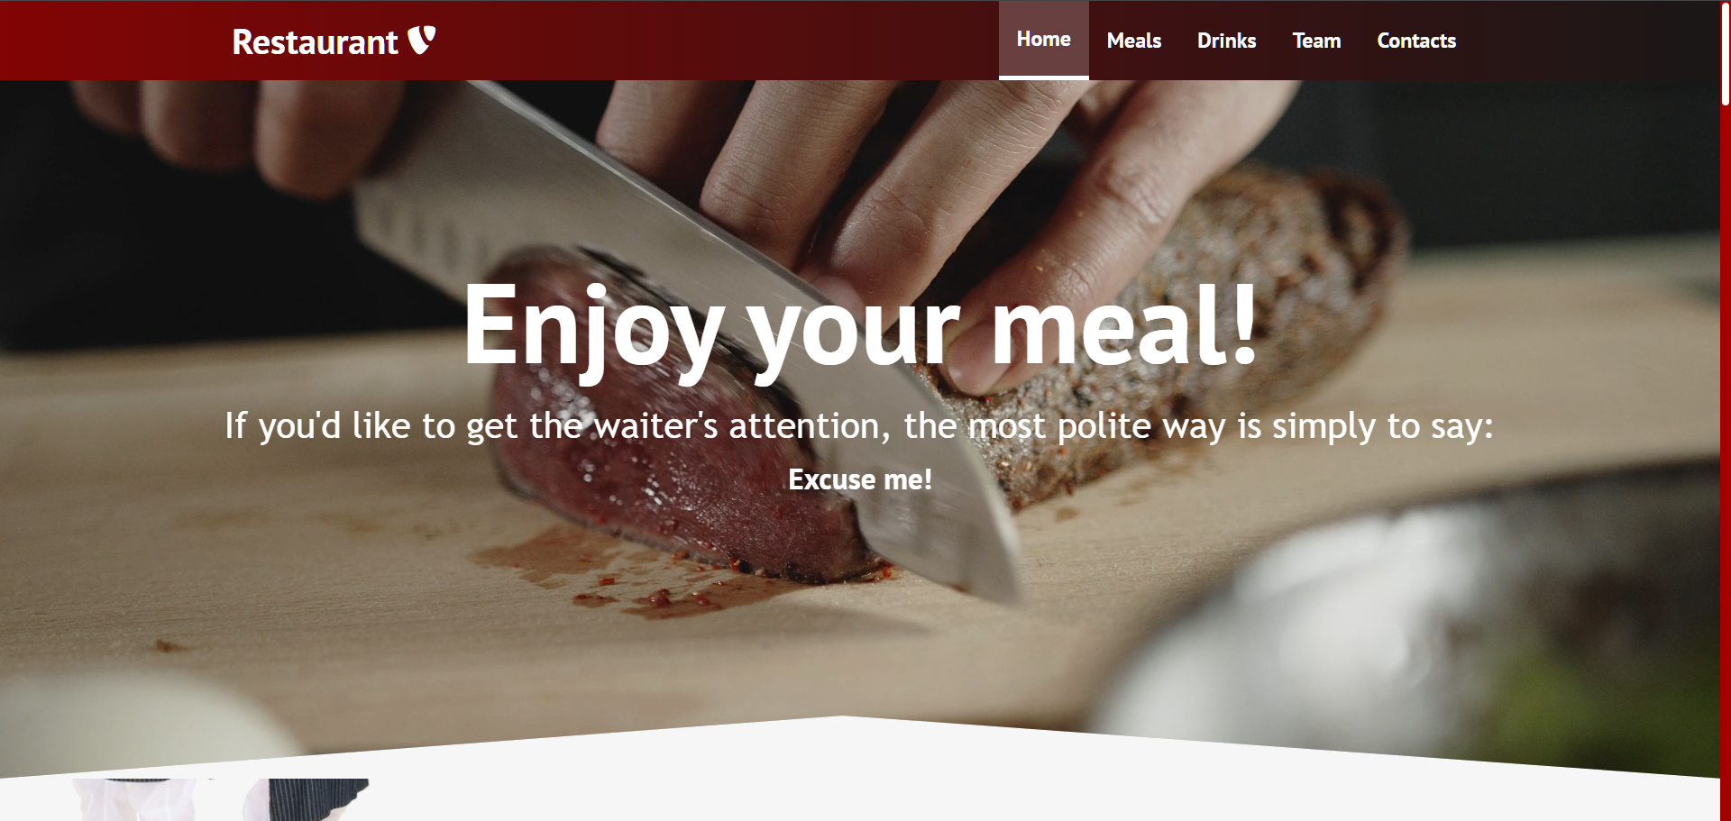

## 1.2 Meals

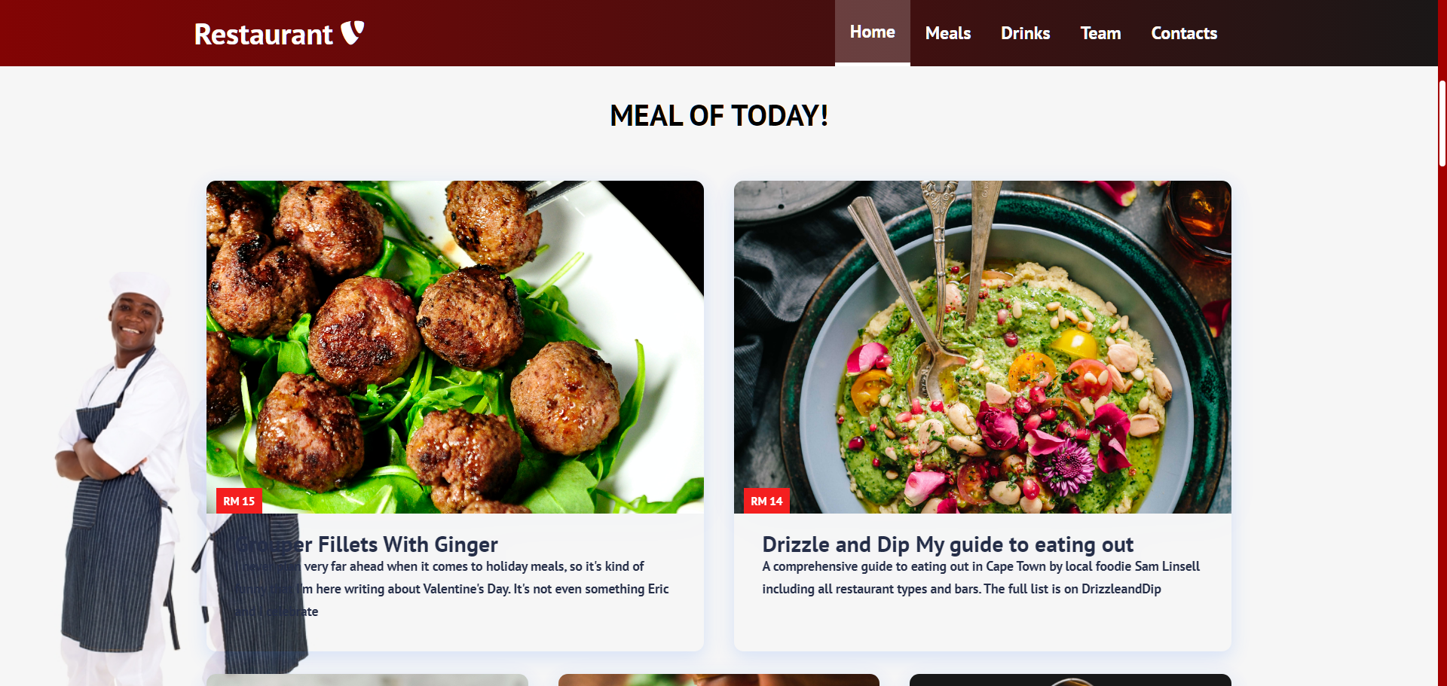

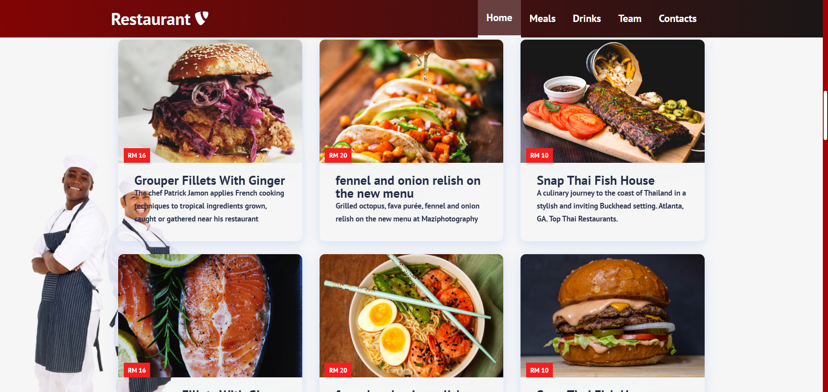

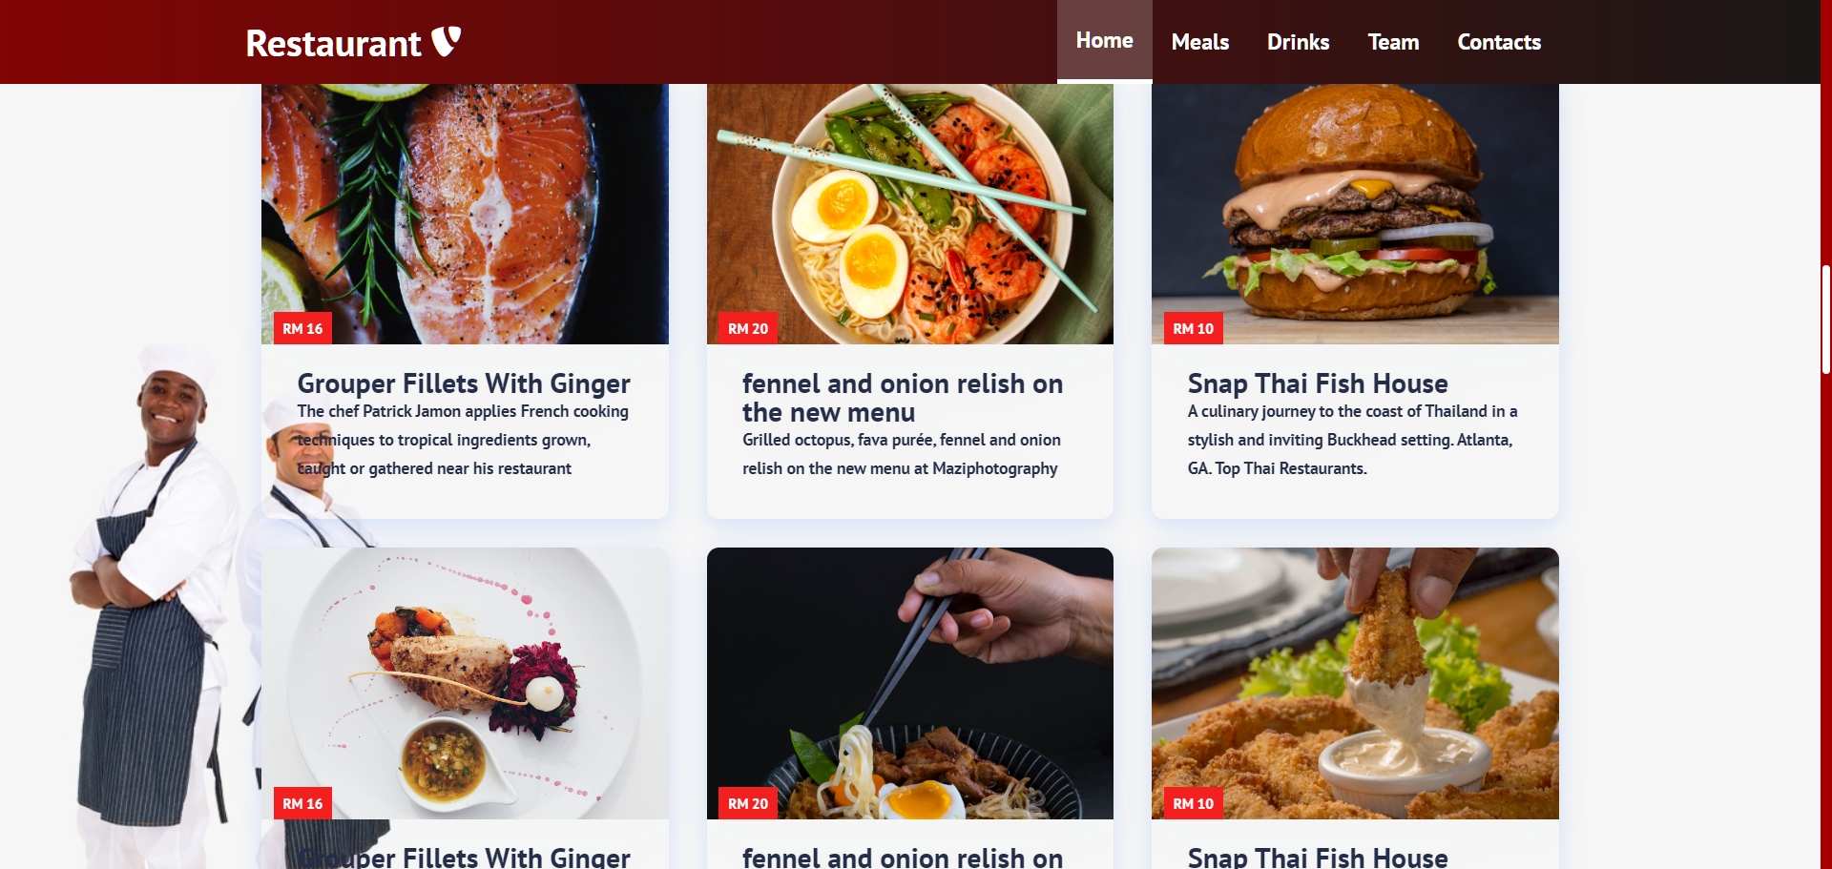

## 1.3 Drinks

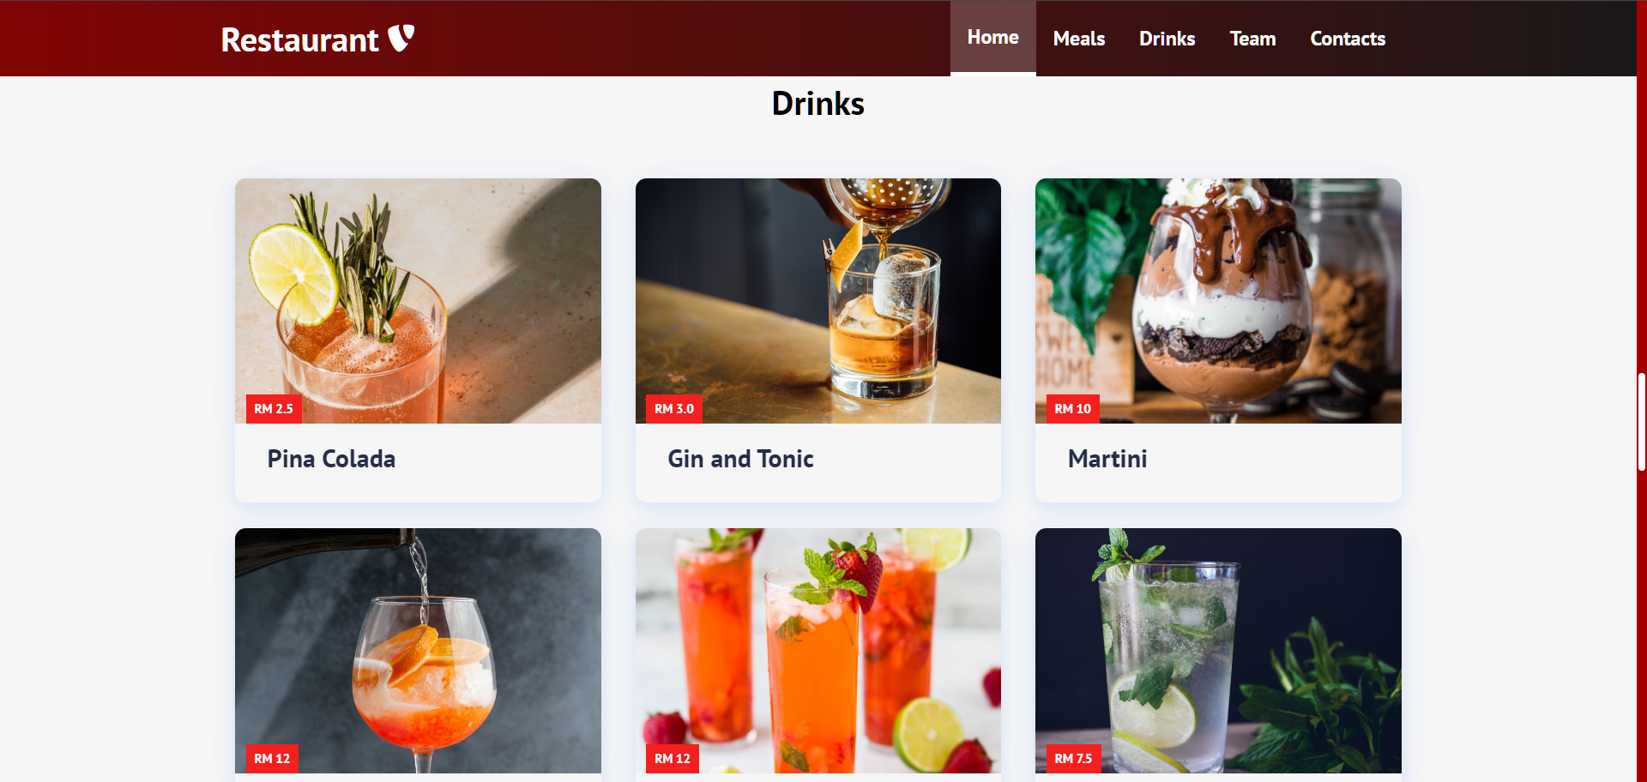

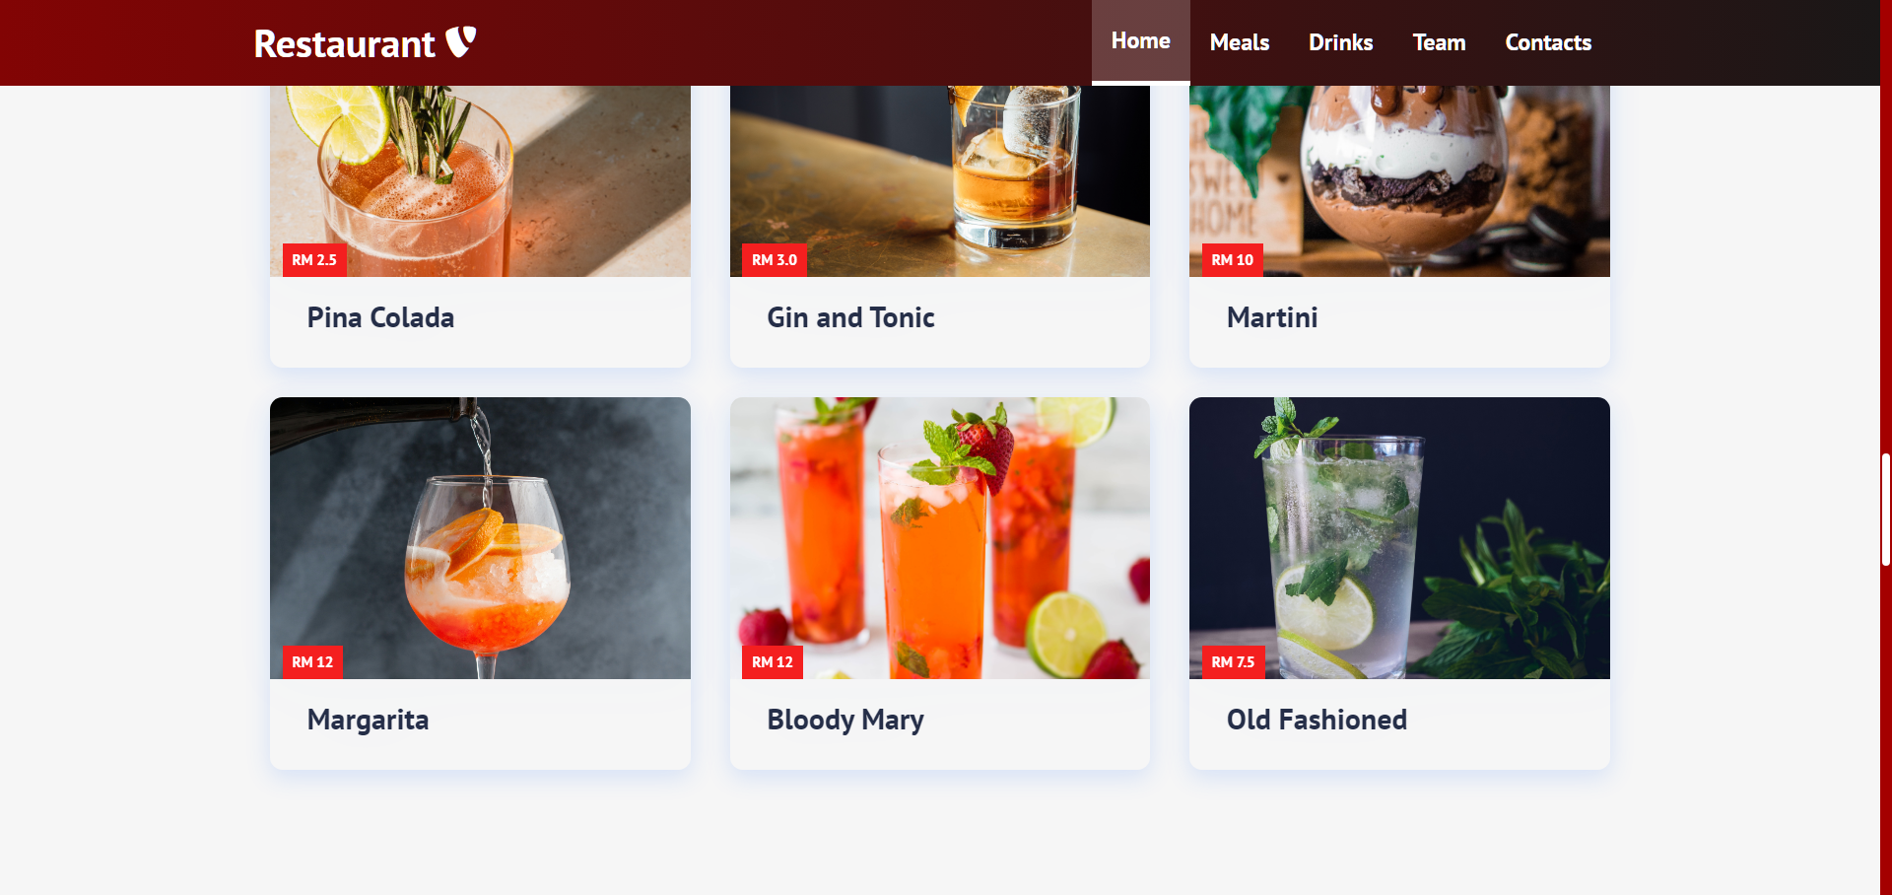

## 1.4 Newsletter Subscription

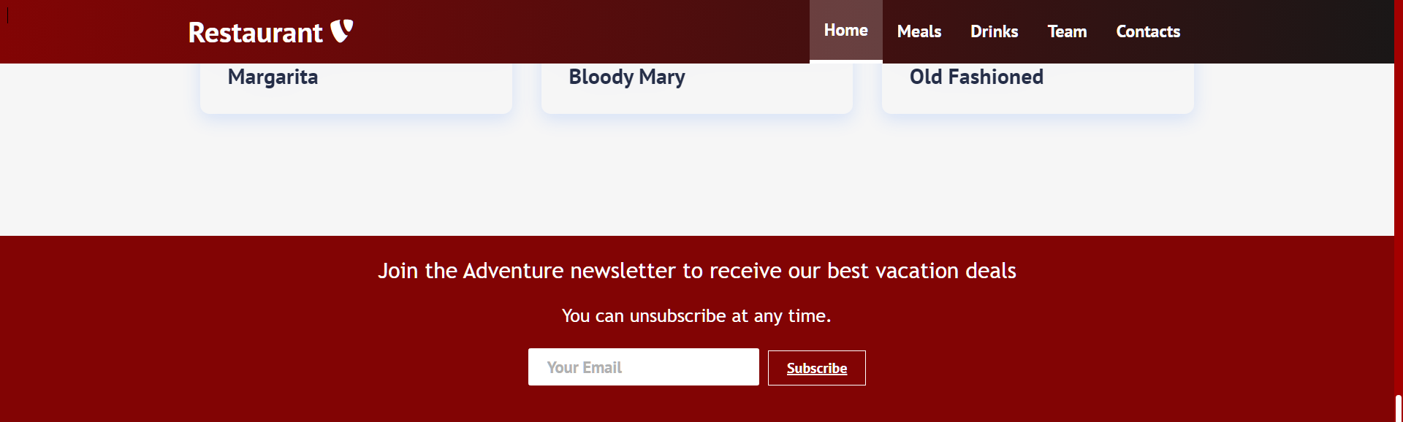

## 1.5 Team

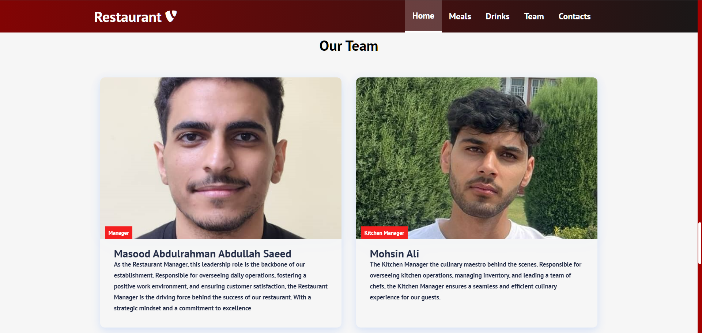

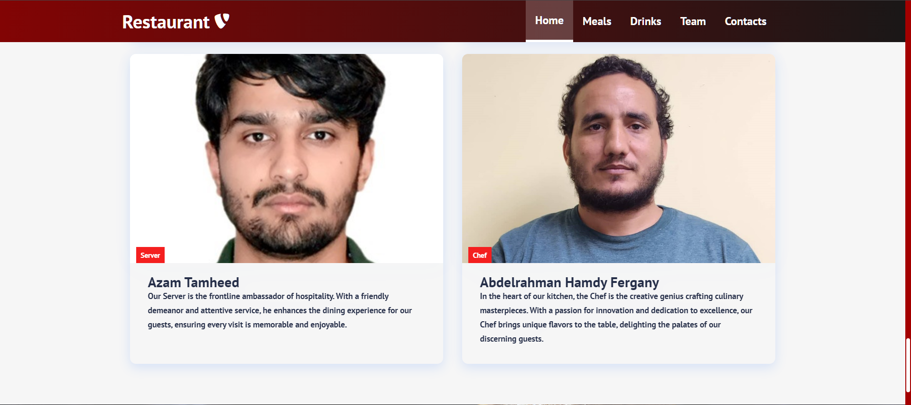

## 1.6 Footer

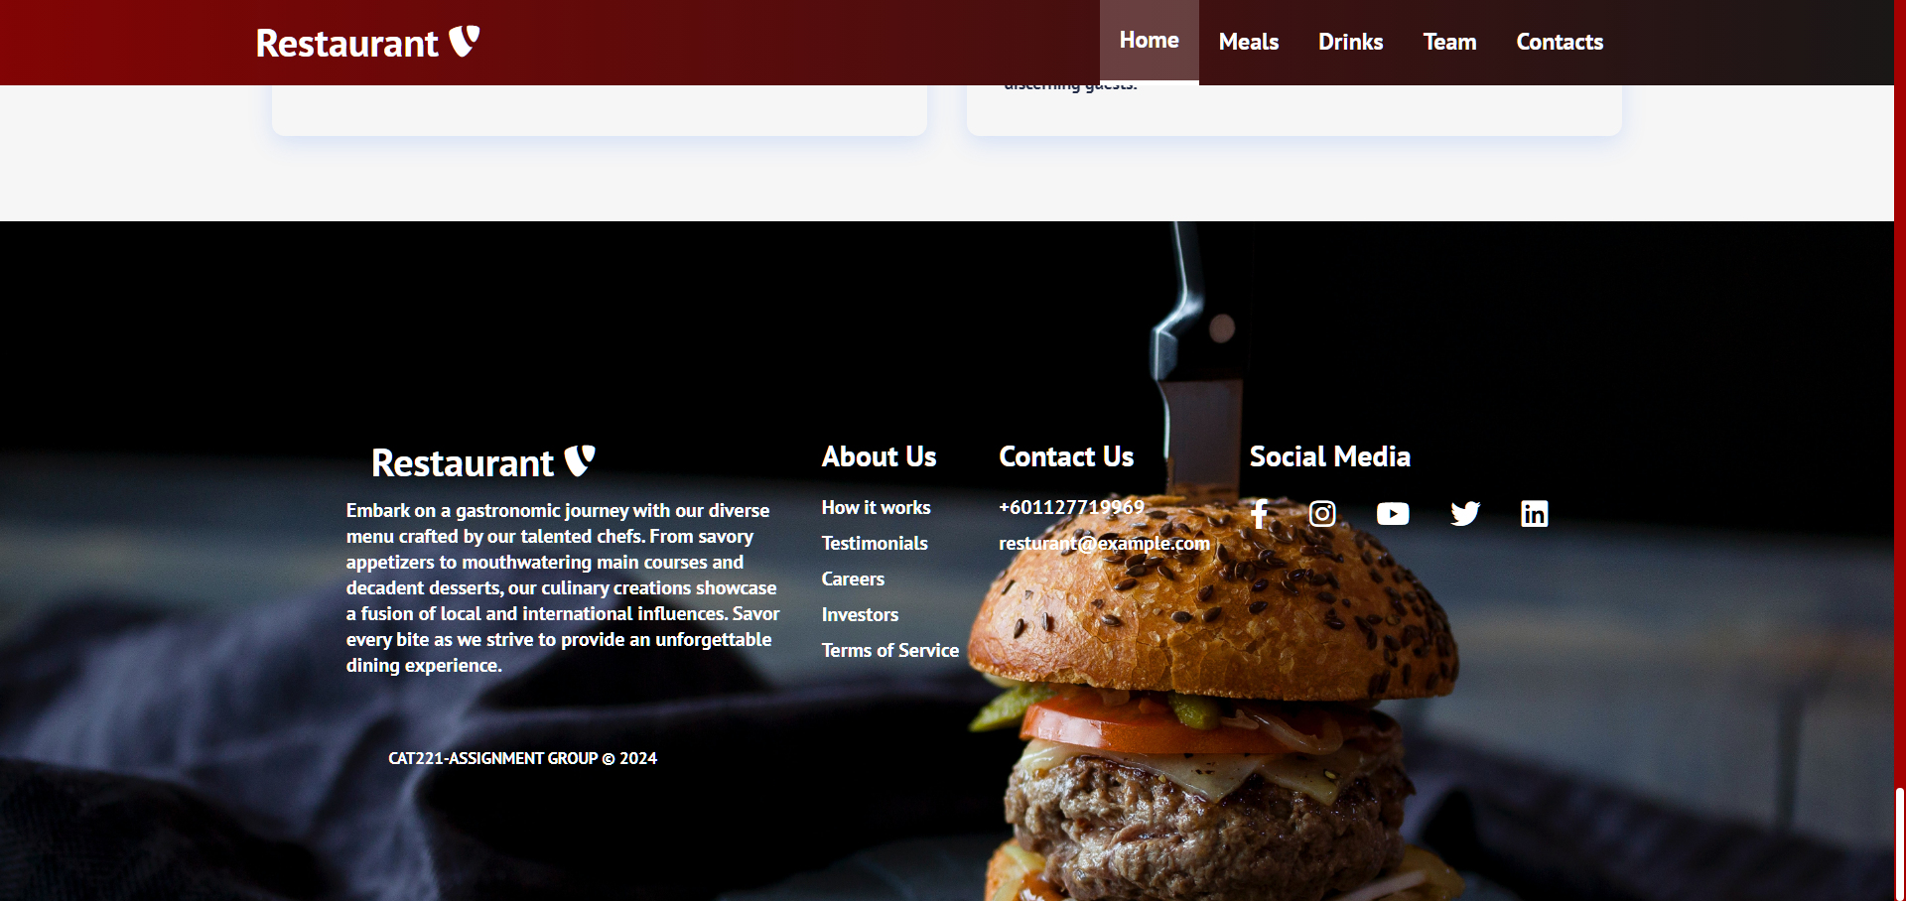

# Individual Scope

## 2.1 Abdelrahman Hamdy Fergany (UI/UX Designer):

* **Home.js**: Design the main landing page, ensuring an engaging and visually appealing layout.
* **CardItem.js and Cards.js:** Design the layout and styling for individual cards and the card container, ensuring a cohesive design for displaying content.
* **Footer.js:** Create a visually appealing and informative footer for the application.

## 2.2 Masood Abdulrahman Abdullah Masood, Frontend Developer (Main Components):

* **App.js:** Implement the main structure of the application, integrating the various components and managing the overall state.
* **index.js:** Configure the React app's entry point and render the main App component.
* **Subscription.js:** Implement the subscription component, allowing users to subscribe for newsletters.

## 2.3 Mohsin Ali, Frontend Developer (Card Components):

* **CardItem.js and Cards.js:** Implement the functionality for individual cards and the card container, ensuring proper data rendering and interaction.
* **DrinksCards.js:** Create a specialized component for displaying drink-related cards, implementing any specific functionality related to drinks.

## 2.4 Azam Tamheed, Integration ( UI/UX Designer):

* **Navbar.js:** Design the navigation bar for seamless navigation and a responsive user experience.
* **TopSection.js:** Work on the design and layout of the top section of the landing page, providing an impactful introduction..
* **Button.js**: Design and style the various buttons used throughout the application for a consistent and attractive appearance.

# Developmental and Design Work

## 3.1 Abdelrahman Hamdy Fergany (UI/UX Designer):

As the UI/UX Designer for this React application, my primary focus was on creating a visually appealing user interface. I designed the Home.js component to capture the essence of the application, ensuring a seamless and engaging experience for users. The challenge involved striking the right balance between aesthetics and functionality, considering the diverse components that I had to work on. Collaborating closely with frontend developers, I Managed to overcome design challenges and provided solutions that enhance the overall user system.

## 3.2 Masood Abdulrahman Abdullah Masood, Frontend Developer (Main Components):

As the frontend developer responsible for the main components, my focus was on implementing the core structure of the React application. App.js served as the foundation, integrating various components, and index.js was configured as the entry point. Additionally, I implemented the Subscription.js component, enabling users to subscribe or sign up for newsletters. I overcame obstacles by effectively communicating with the UI/UX designer to ensure the proper integration of design elements.

## 3.3 Mohsin Ali, Frontend Developer (Card Components):

In my role as the frontend developer responsible for card components, I tackled the implementation of CardItem.js and Cards.js. These components play a crucial role in displaying and managing most of the content such as the meals, drinks and team cards, presenting a challenge in terms of data rendering and user interaction. Collaborating with the UI/UX designer, I ensured the seamless integration of design elements and responsiveness across devices. The development of DrinksCards.js involved creating a specialized component for drink-related content, introducing additional complexity.

## 3.4 Azam Tamheed (UI/UX Designer):

In my capacity as the UI/UX Designer for this React application, my primary focus centered on crafting an aesthetically pleasing user interface. I specifically designed the Button.js, Navbar.js, and TopSection.js, to embody the application's core essence. The challenge lay in striking the right balance between aesthetics and functionality, especially given the diverse components I had to address. Collaborating closely with frontend developers, I successfully overcame design challenges, providing solutions that enhance the overall user system.